Q1. Read the nba.csv file to create a Pandas DataFrame. Test whether or not any data is missing. If yes, show the records that missing value(s).

Q2. Group the data by Team and Year, display each team’s, each year’s TeamPoints and OpponentPoints.

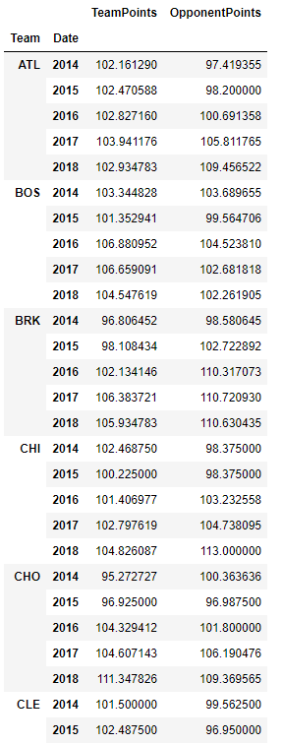

Q3. Create another DataFrame named nba_2017 where it contains records of year 2017. In this DataFrame, you should have 2,536 rows.

Q4. Draw a bar chart for all teams’ average TeamPoints per game in 2017. Add an appropriate x_label, y_label and title to the chart (NO SUCH THINGS IN THE FOLLOWING EXAMPLE FIGURE). Use an appropriate size for the chart.

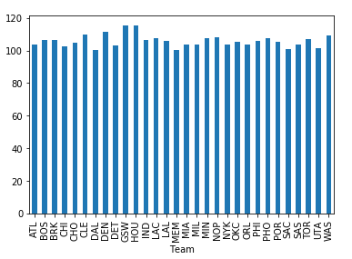

Q5. Display the top 5 teams in 2017 with the best defending in terms of least OpponentPoints. The output should contain the Team’s name and the average OpponentPoints per game.

Q6. Draw a stacked column chart showing the numbers of W and L for each team. Add an appropriate x_label, y_label and title to the chart (NO SUCH THINGS IN THE FOLLOWING EXAMPLE FIGURE). Use an appropriate size for the chart.

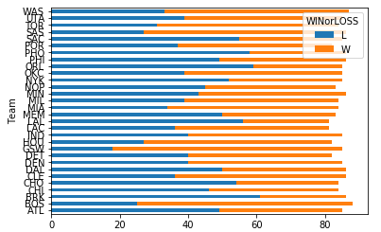

Q7. There is an important metric to evaluate a team’s performance which is the difference between it scores and its opponent scores. Show all teams with this metric from the largest to the smallest.

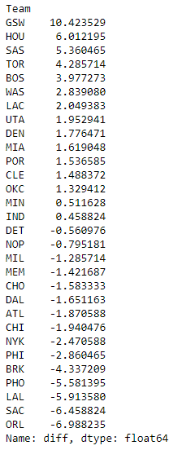

Q8. Draw a scatter plot chart using all Houston Rocket’s games’ TeamPoints and OpponentPoints. Add an appropriate x_label, y_label and title to the chart (NO SUCH THINGS IN THE FOLLOWING EXAMPLE FIGURE). Use an appropriate size for the chart.

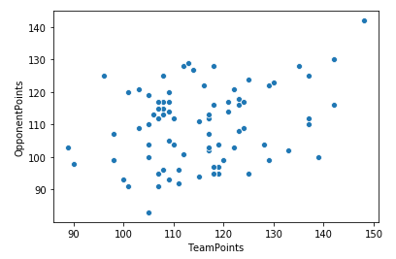

Q9. Display the winning rates of Houston Rockets’ Home games and Away games in 2017.

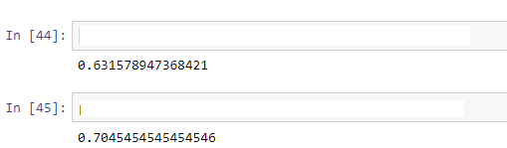

Q10. Draw a line chart for Houston Rockets’ FieldGoals, 3PointShots and FreeThrows success rates. Add an appropriate x_label, y_label, markers and title to the chart (NO SUCH THINGS IN THE FOLLOWING EXAMPLE FIGURE). Use an appropriate size for the chart.

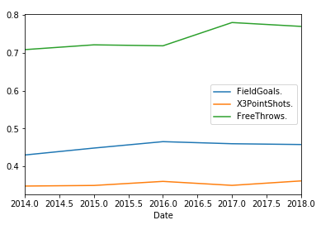

Q11 Show the number of winning games for each team, each year.

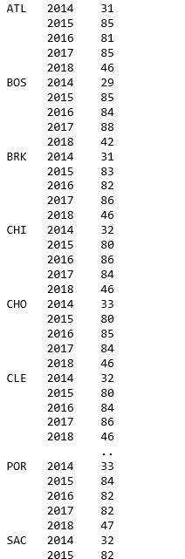

Q12. Create a figure of subplots where it compares the numbers of winning games of HOU and GSW.

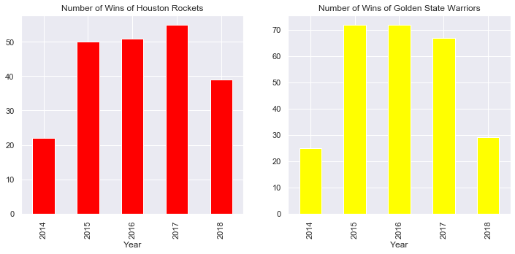

Q13. Create the following charts based on TeamPoints. Use bins=20.

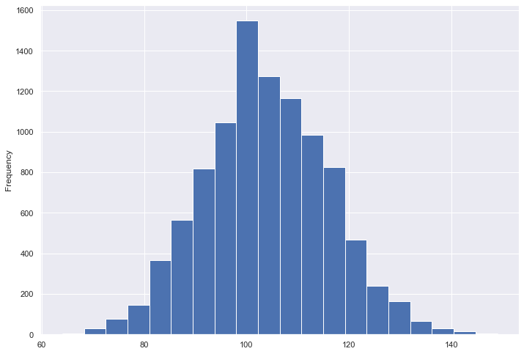

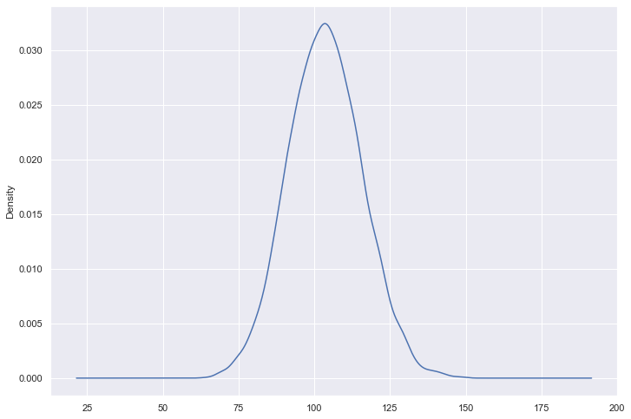

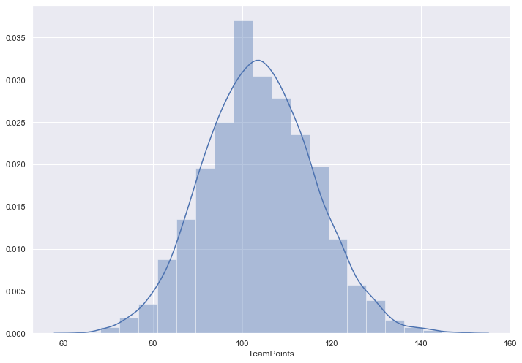

Q14. Draw a heat map based on average TeamPoints for each team, and each year.

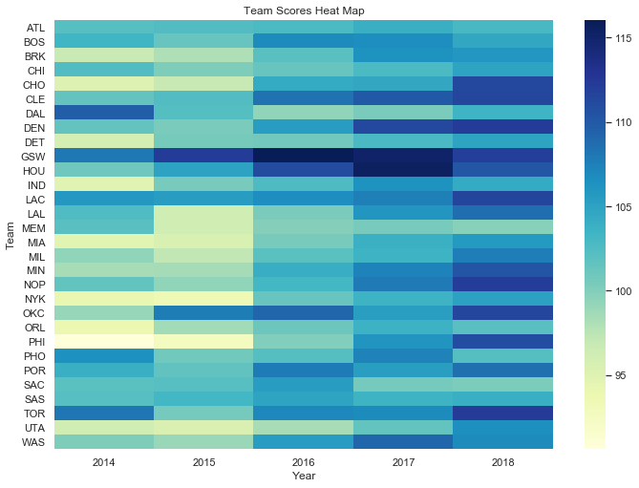

Q15. Display the teams where their FieldGoals. is >= 0.45 and their Opp.FieldGoals. is < 0.45.

